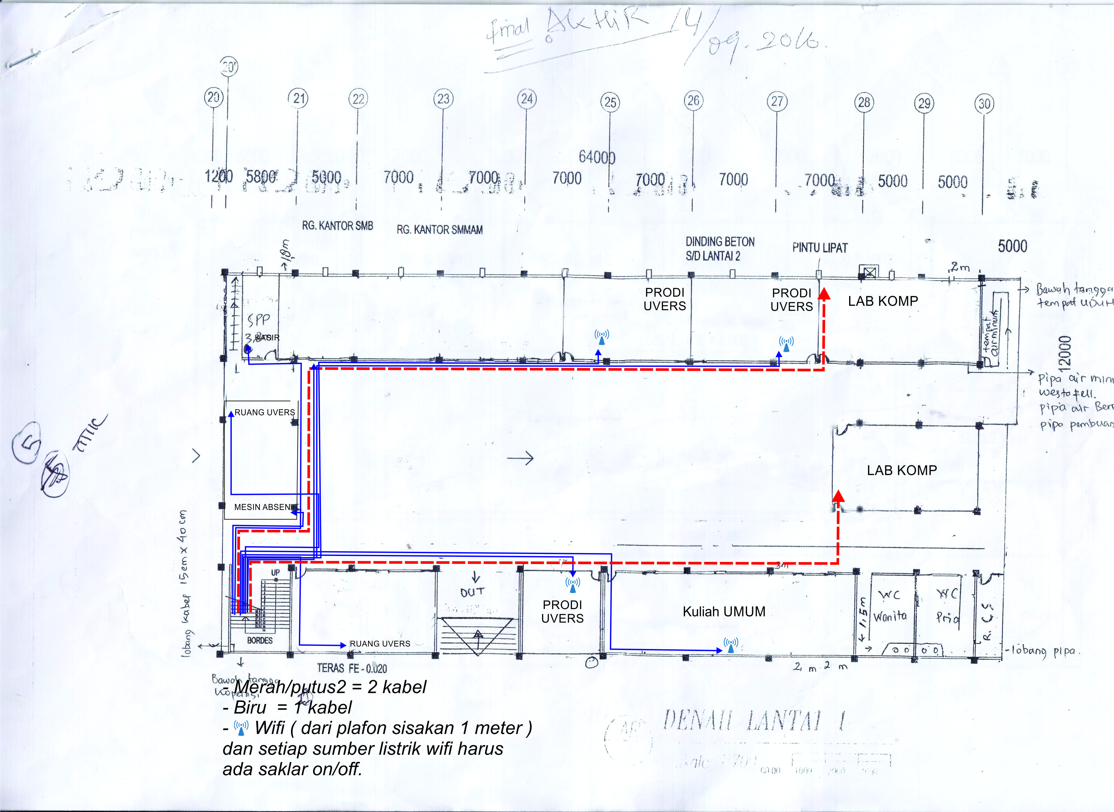

**Ruang Tari**

**Studio Tari 2**

**Studio Tari 1**

**C.109**

**C.108**

**C.102**

**C.107**

**C.106**

**C.105**

**C.103**

**C.104**

**C.101**

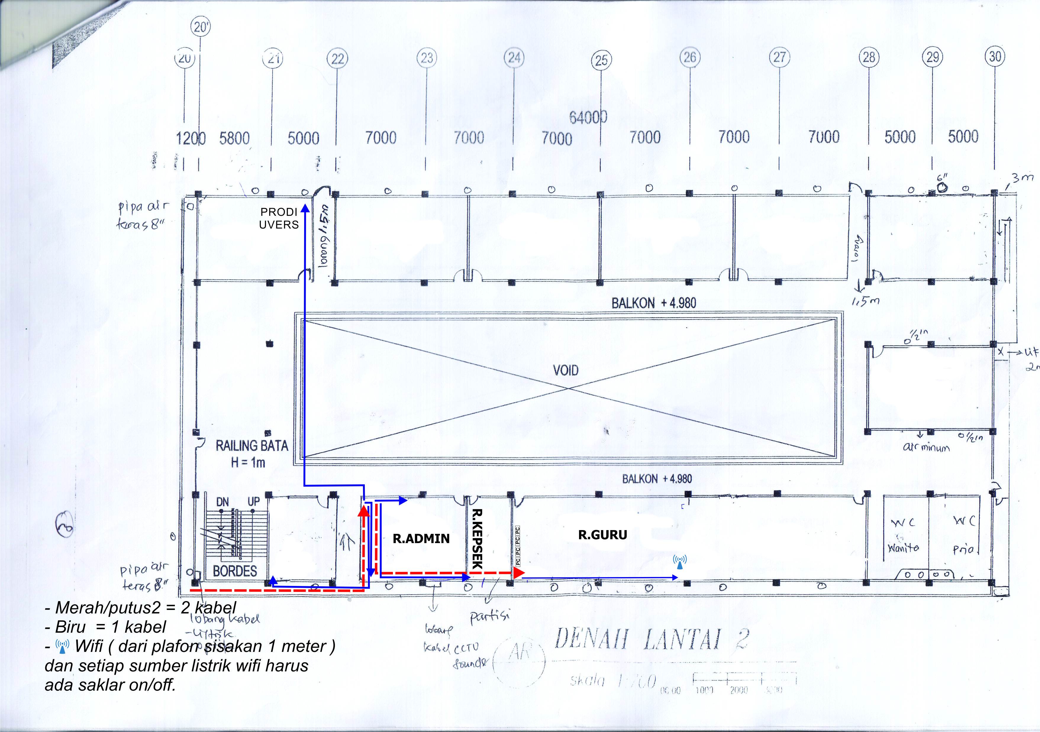

**UCC**

**K6**

**K5**

**K4**

**K3**

**K2**

**K1**

**C.211**

**C.210**

**C.209**

**C.208**

**C.207**

**C.206**

**C.205**

**C.204**

**C.203**

**C.201**

**C.202**

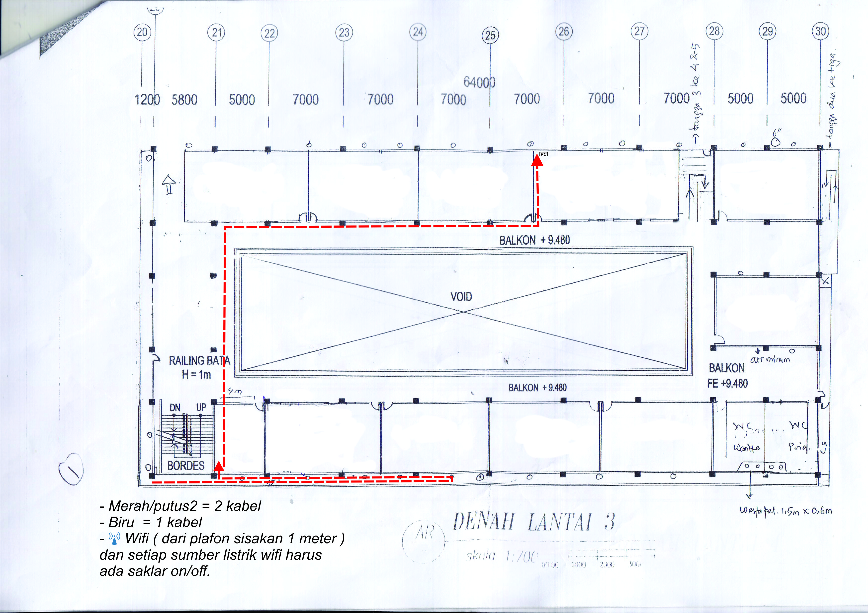

**C.305**

**C.312**

**C.311**

**C.310**

**C.309**

**C.308**

**C.307**

**C.306**

**C.304**

**C.303**

**C.302**

**K16**

**K15**

**K14**

**K13**

**K12**

**K11**

**K10**

**K9**

**K8**

**K7**

**C.301**

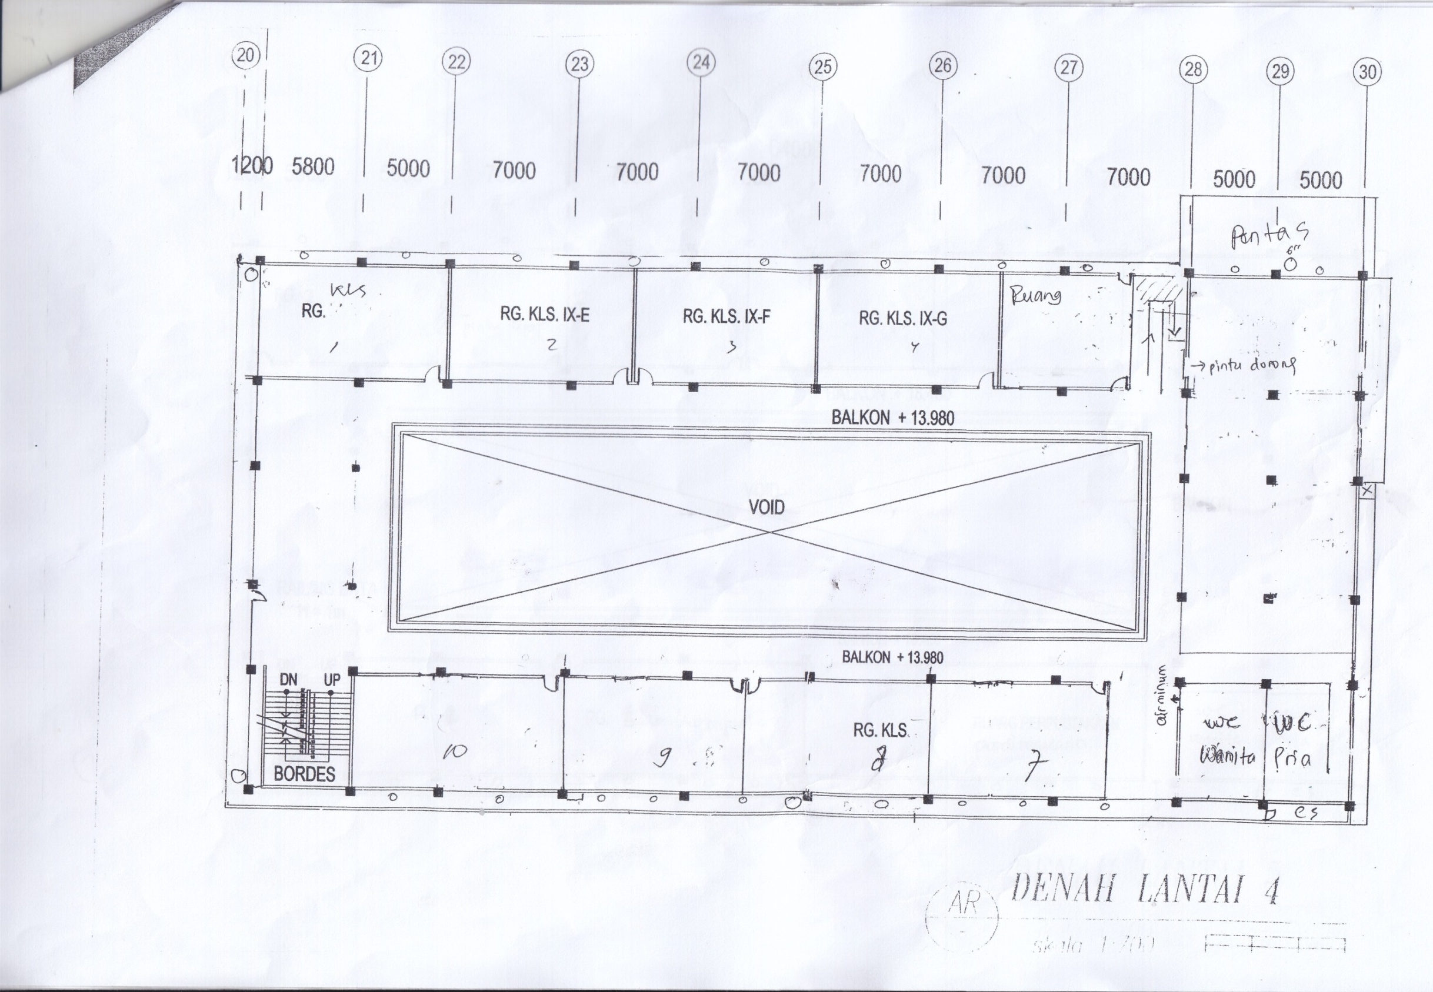

**C.404**

**C.403**

**C.402**

**C.401**

**C.400**

**C.405**

**K20**

**K19**

**K18**

**K17**

**MINI AUDITORIUM**

**C.410**

**C.409**

**C.408**

**C.407**

**C.406**

**K23**

**K24**

**K22**

**K21**

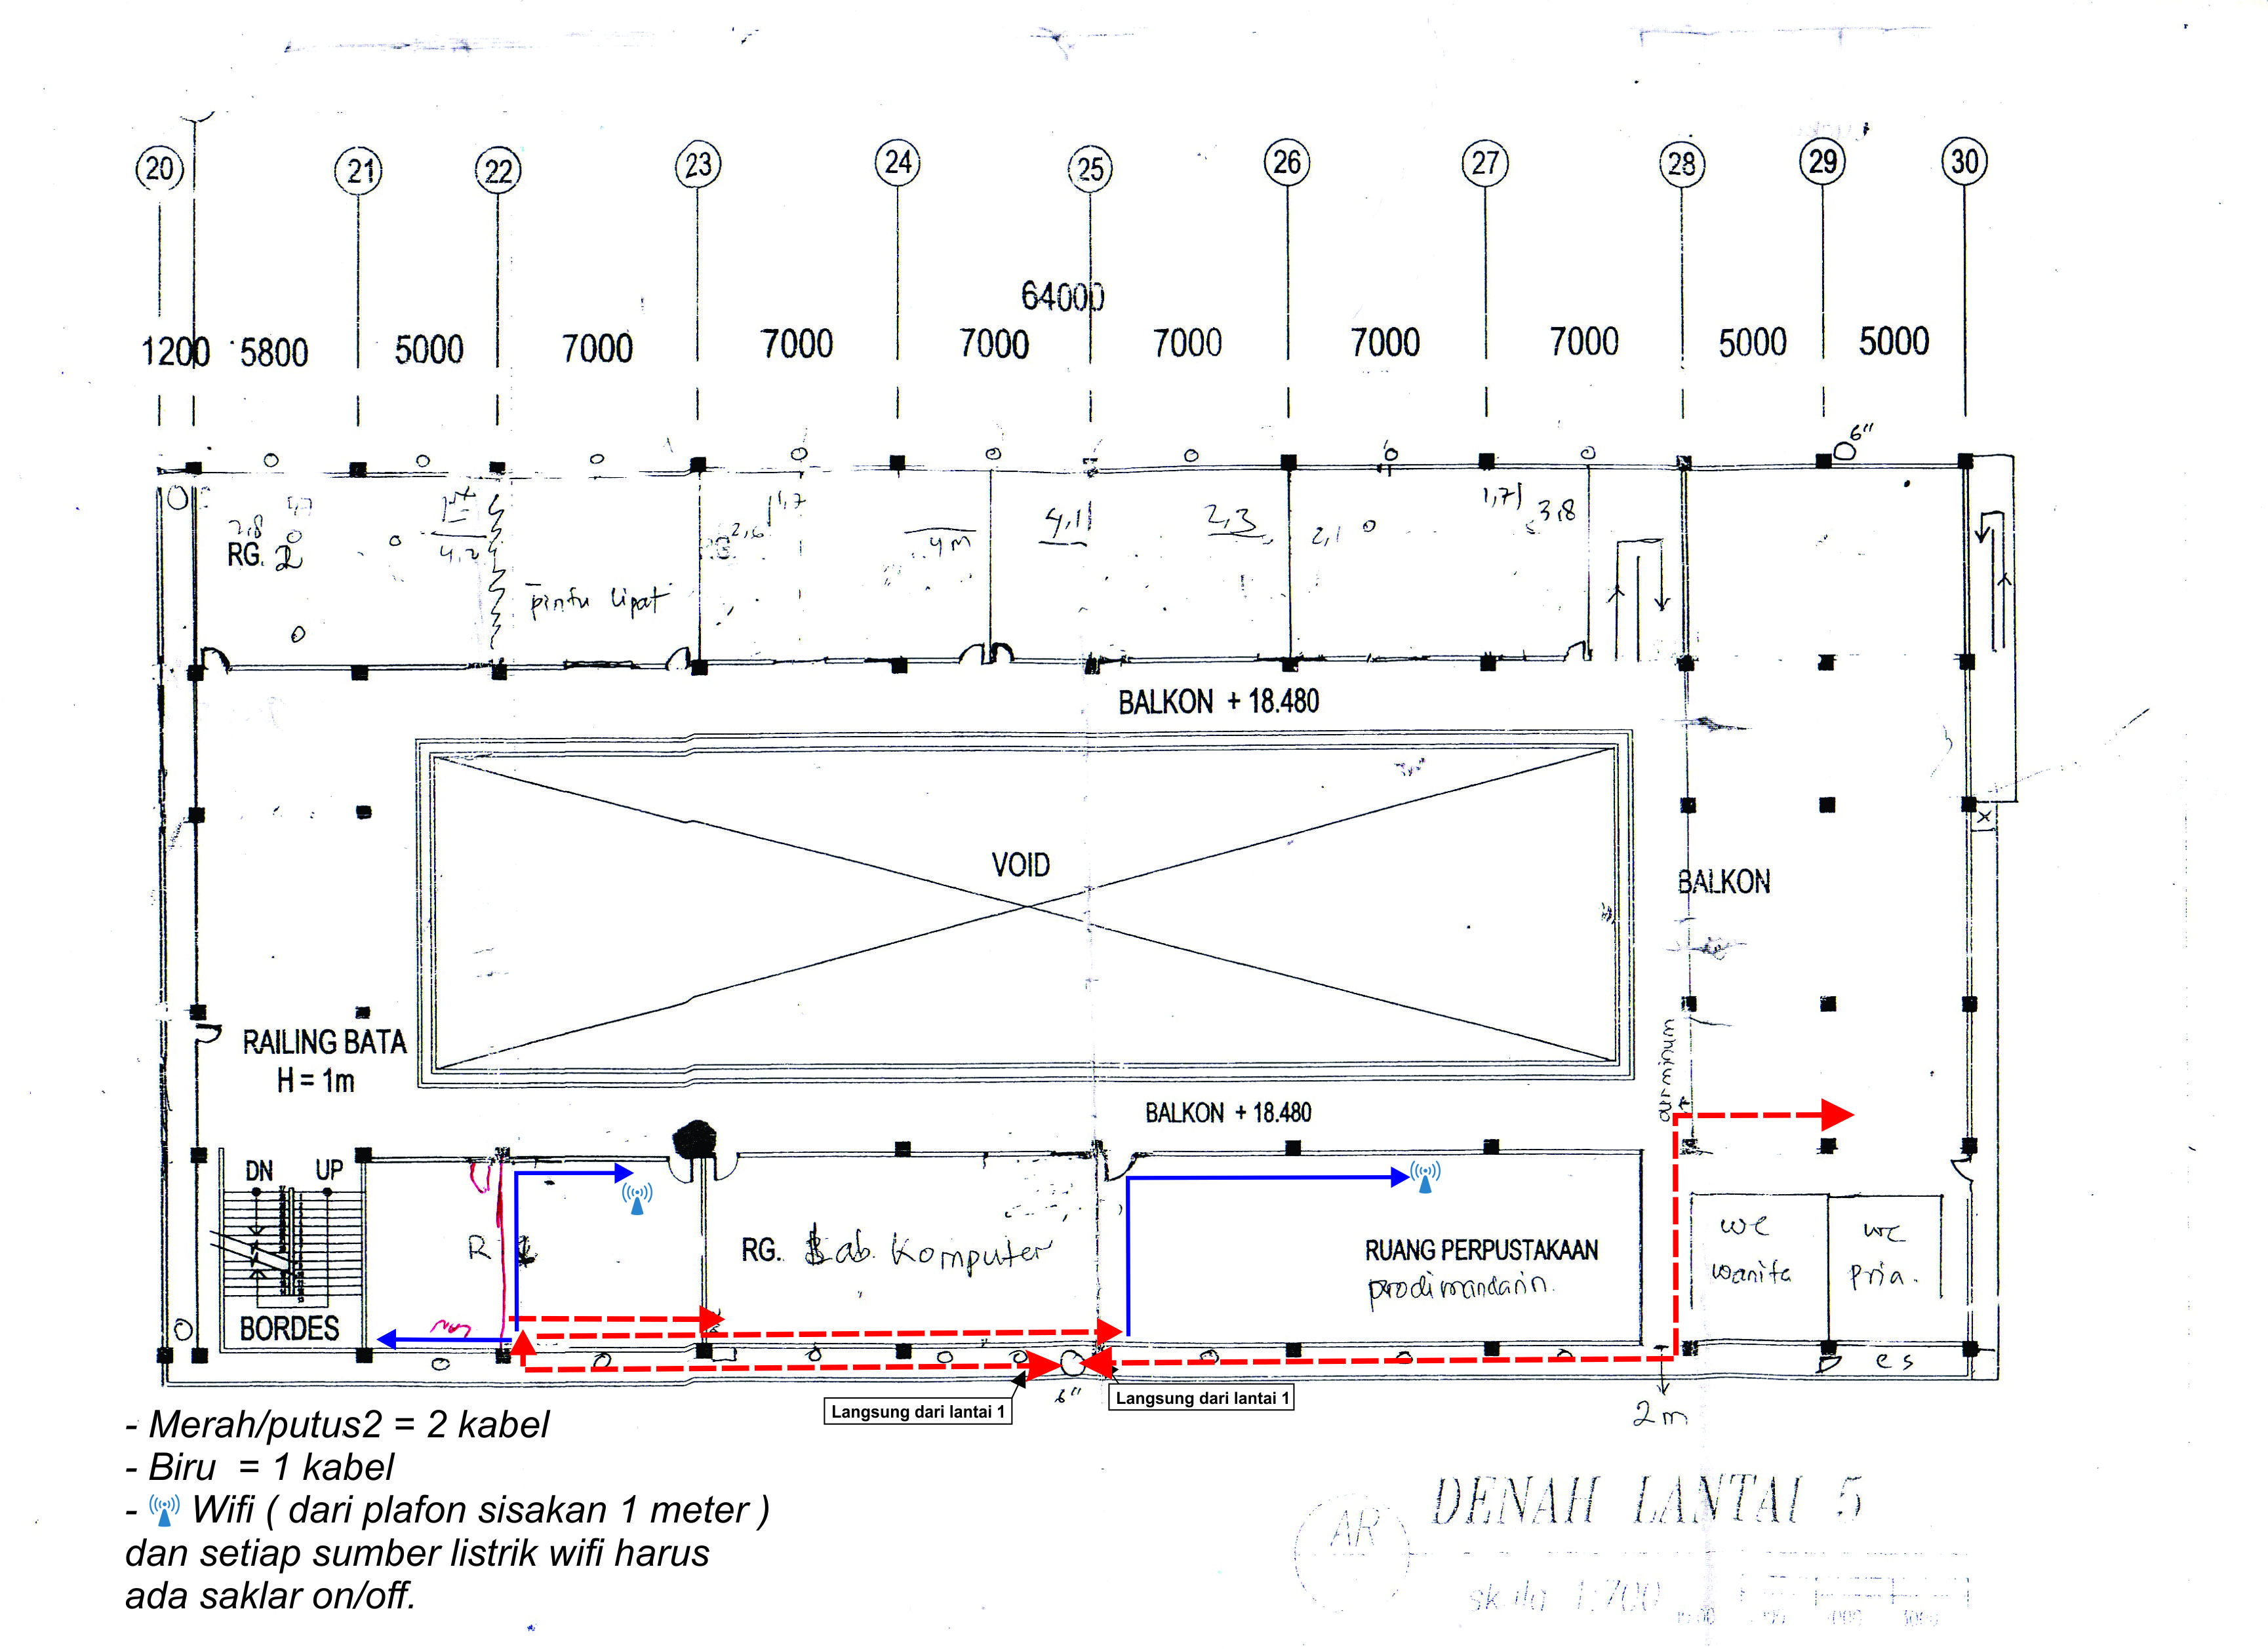

**MINI AUDITORIUM**

**C.508**

**C.507**

**C.506**

**C.505**

**C.500**

**C.504**

**C.503**

**C.502**

**C.501B**

**C.501A**

**KM3**

**KM2**

**KM1**